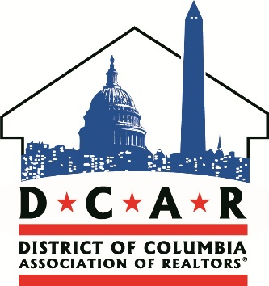
For Immediate Release:  12/14/15 | Contact: Daniel Wise Communications Associate  202-615-2481
DC REALTORS® Elect New Board of Directors, Install President Angela Jones
Washington, DC — Recently the District of Columbia Association of REALTORS® held its annual Holiday Party and Board Installation at the Atlas Performing Arts Center in Northeast Washington, DC. Members of the Association attended to vote on nominations for the 2016 President and Board of Directors. Angela Jones was elected to lead their advocacy efforts next year.
Following her installation, Jones said, “I am eager to begin leading the DC Association of REALTORS® in 2016 to further the interests of the real estate community and the public we serve.” She added, “We have made great strides to address issues affecting home buyers and sellers in the District, and the Council is listening to our collective voice.”
Angela Jones succeeds the Association’s 2015 President Ed Wood. In his State of the District address, Wood said “We have made great strides to bring outmoded legislation to the attention of the Council. Moving forward, I believe President Angela Jones will continue the good will DCAR has built up with the District government and its communities to make lasting changes to legislation that benefit consumers who wish to call DC home.”
Angela Jones is a REALTOR® with Long & Foster Real Estate, Inc. A real estate professional for over 10 years, Jones has served DC’s Northeast neighborhoods and has settled in the Brookland neighborhood with her wife Donna. Jones served for four years on DCAR’s Board of Directors before her nomination as President.

The DC Association of REALTORS® is a state-level association representing over 2,600 residential and commercial REALTORS® who are licensed in the District of Columbia. The DCAR RPAC Trustees are an independent decision-making entity appointed by the Board of Directors. They review and potentially endorse District candidates who are best suited to support REALTOR® interests with our resources. This year's Trustees are all former DCAR Presidents.
Follow DCAR for the latest news and live event media updates.
###

