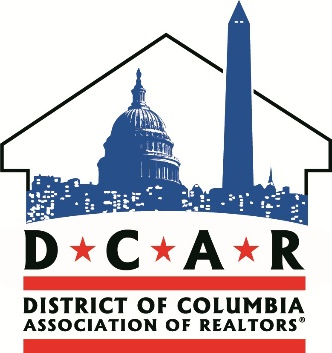
For Immediate Release:  02/10/16 | Contact: Daniel Wise Communications Associate  202-615-2481
DC REALTORS® Advocate for First-Time Homebuyers on Landmark Tax Benefit Bill
Washington, DC — Today the District of Columbia Association of REALTORS® (DCAR) gave testimony to the DC Council’s Committee on Finance and Revenue supporting the “First-Time Homebuyer Tax Benefit Amendment Act of 2015.” The bill aims to reduce the recordation tax rate for first-time buyers who have never owned real property in the District of Columbia. The Association expressed high level support for the bill when it was introduced in 2014 and continues to support it from its re-introduction in 2015.
The bill was re-introduced by Councilmembers David Grosso (I-At Large), Jack Evans (D-2) and Anita Bonds (I-At Large); it was co-sponsored by Yvette Alexander (D-7) and Charles Allen (D-6). If enacted, the recordation tax rate for first-time homebuyers in DC would reduce from 1.45% to 0.725%.
“The first-time homebuyer tax benefit is a potential huge win for people who wish to settle in the District,” said 2016 DCAR President Angela Jones. She added, “I can’t count how many times I lost prospective buyers who decided to look outside of DC due to the excessive out-of-pocket expense required to pay the recordation tax.” Several DC REALTORS® and title attorneys presented testimony alongside Mrs. Jones to support the bill.
DCAR CEO Ed Krauze applauded the work of Councilmembers Grosso, Evans and Bonds who turned to REALTORS® to help craft the legislation. “When Councilmember Grosso envisioned the bill, he immediately reached out to the Association for its insight and ideas.” He added, “David has been a great friend to DC’s real estate community, and his willingness to bring us to the table is a reflection of his good will.”
The Association is thrilled to see Councilmembers Grosso, Bonds and Evans continue to take steps to make home ownership a reality for many families who wish to plant roots in the District of Columbia. We thank them for their steady focus on DC’s residents, neighborhoods and communities. Reducing the recordation tax rate will leave a positive impact for years to come.
The DC Association of REALTORS® is a state-level association representing over 2,600 residential REALTORS® and affiliates who are licensed in the District of Columbia. As the voice of real estate in DC, the Association advocates on behalf of its members and the public they serve.
Follow DCAR for the latest news, live events and media updates.
###

