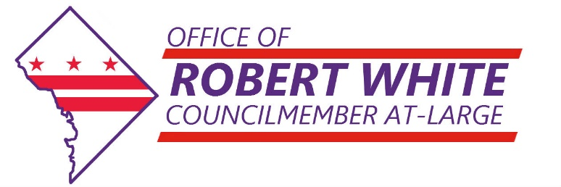

**For Immediate Release:** 02/09/2017

**Contact:** [Daniel J. Wise](mailto:dwise@dccouncil.us), Communications & Outreach Specialist (202) 256-7154

Follow At-Large Councilmember Robert White

**[cid:image002.png@01D256CF.7C8844D0](https://www.facebook.com/RobertWhiteAtLarge)[cid:image003.png@01D256CF.7C8844D0](https://twitter.com/robertwhite_DC)[cid:image004.png@01D256CF.7C8844D0](https://www.instagram.com/robertwhite_dc/)**

**Councilmember White Requests Major Investment to Bridge Gaps for the Poor in Mayor’s Fiscal Year 2018 Budget**

Washington, DC - At-Large Councilmember Robert White sent a letter to Mayor Bowser requesting funding for programs critical to help bridge economic divides in the District of Columbia. Councilmember White is using his first full term in office to focus on the issues he championed during his 2016 election, including education, workforce development, affordable housing, and returning citizens. He prioritized these issues in his letter to the Mayor stating that he believes they share these priorities.

Councilmember White’s request comes after the Mayor released the 2016 Comprehensive Annual Financial Report, which shows the strongest ever financial position for the District. White noted that reading between the lines of this strong financial report it is clear that the city faces a great risk by not addressing the growing income gap and dangerously small middle class. He said, “I believe the District of Columbia faces a long-term liability to our prosperity and stability as a result of persistent income and wealth inequality.”

To address these risks, Councilmember White requested the following six budget additions:

* An additional $17.4 million for affordable housing programs to help end homelessness.
* Increased funding for the production, rehabilitation, and preservation of affordable housing.
* $3 million towards public transportation for adult students trying to gain valuable skills for employment.
* Funding to help returning citizens, who face severe employment discrimination, start their own business.
* Two new permanent, full-time employees for the Mayor’s Office on Returning Citizens Affairs to better assist returning citizens in finding housing and employment.
* Resources for the Department of Health to fight HIV/AIDS through prevention medication.

Councilmember White emphasized the importance of providing robust programs and services for all District residents. He stated, “I will constantly advocate for the need to invest in stronger schools, stable housing, and jobs.” He added, “These are the biggest factors in creating stable families, reducing crime, and building a middle class. This is the way to bridge the gap between those who have benefited from our recent economic growth and those who are being left behind.”

*The full letter to Mayor Bowser is attached. Councilmember Robert White has served the District as an At-Large Councilmember since September 16, 2016. His focus is on education, workforce development, affordable housing, and returning citizens.*

###