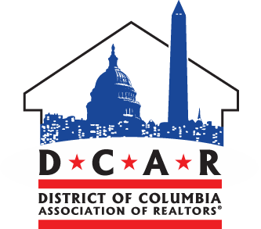
For Immediate Release:  04/27/2016 | Contact: Daniel Wise  Communications Associate | 202-615-2481

DC State REALTOR® Association to Host At-Large DC Council Candidate Debate Friday
Washington, DC —The District of Columbia Association of REALTORS® (DCAR) will host a Candidate Debate for DC’s At-Large Councilmember this Friday 12:30 PM, April 29, 2016, at the National Association of REALTORS® (NAR) building located at 500 New Jersey Avenue, NW. The debate will feature three candidates who are seeking the Democratic Party nomination on DC’s June 14 Primary Election Day. The candidates attending the debate include incumbent Councilmember Vincent Orange and challengers Robert White and David Garber. Debate topics will focus primarily on issues related to housing, regulations, and economic development.

DCAR selected Brenda Small to moderate. She most recently served as NAR Region 3 Vice President and currently serves as NAR Federal Political Coordinator DC representative to Congresswoman Eleanor Holmes Norton. Vice President Small said, “I am thrilled DCAR is hosting the At-Large Democratic Primary Debate.” She added, “I don’t plan to hold anything back with my questions, and I am eager to see how the candidates react.”

DCAR's Debate Series puts REALTOR® members in front of the candidates who may represent DC's vibrant and tight-knit neighborhoods in the government. The Association works to foster an active and engaged community of real estate professionals at all levels.

DCAR President Angela Jones added her perspective. She explained, "This candidate debate provides an excellent opportunity for REALTORS® to hear where the candidates stand on opportunities and challenges with affordable housing, economic development and the unintended consequences of government regulations such as TOPA (Tenant Opportunity to Purchase Act)."

The DC Association of REALTORS® is a state-level association representing nearly 2,600 residential REALTORS® who are licensed in the District of Columbia. The DCAR RPAC Trustees are an independent decision-making entity appointed by the Board of Directors. They review and potentially endorse District candidates who are best suited to support REALTOR® interests with our resources. This year's Trustees are all former DCAR Presidents.
Follow DCAR for the latest news and live event media updates.
###

