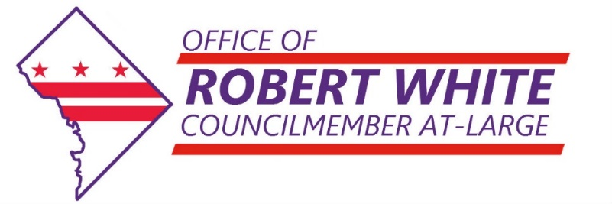

**For Immediate Release:** May 16, 2017

**Contact:** [Daniel Wise](mailto:dwise@dccouncil.us), Communications & Outreach Specialist (202) 256-7154

Follow At-Large Councilmember Robert White

**[cid:image002.png@01D256CF.7C8844D0](https://www.facebook.com/RobertWhiteAtLarge)[cid:image003.png@01D256CF.7C8844D0](https://twitter.com/robertwhite_DC)[cid:image004.png@01D256CF.7C8844D0](https://www.instagram.com/robertwhite_dc/)**

**Councilmember White Introduces Bill to Convert Older Office Buildings into Affordable Housing**

Washington DC – At-Large Councilmember Robert White today introduced a bill to begin converting underutilized office buildings in the District of Columbia into affordable housing. The bill, the “Office to Affordable Housing Task Force Establishment Act of 2017,” creates a task force to issue recommendations for public-private partnerships for office-to-affordable housing conversions.

White said, “The District has tons of older office buildings that are sitting mostly vacant because businesses are moving to our newer developments, like City Center and the Wharf, while at the same time we have a severe shortage of affordable housing. We need to connect the dots.”

White, who has a background in economic development policy and has focused on affordable housing since joining the Council last year, said he believes that building owners who are struggling to find commercial tenants would jump at the opportunity to work with the government to put their buildings to productive use. White said, “What we need is for government to take the leadership role in determining what would be required of the government and the private sector to quickly convert our underutilized office buildings into desperately needed affordable housing.”

White noted that the current pace of affordable housing construction is not keeping pace with the need and that the District’s high commercial vacancy rates of nearly 11% are a drag on our local economy. White’s bill brings experts, advocates, and government together to devise recommendations. White said he is confident the task force can deliver because office-to-apartment retrofits are starting to happen across the country, but White says they are not happening quickly enough because no one has taken the lead.

*White serves the District as an At-Large Councilmember. His focus is on education, affordable housing, workforce development, and returning citizens. Additionally, Councilmember White sits on the Committees on Education, Finance and Revenue, Housing and Neighborhood Revitalization, Human Services, and Labor and Workforce Development. Councilmember White has placed an emphasis on affordable housing to bridge the economic divides by ensuring that residents are not priced out of the District of Columbia.*

###