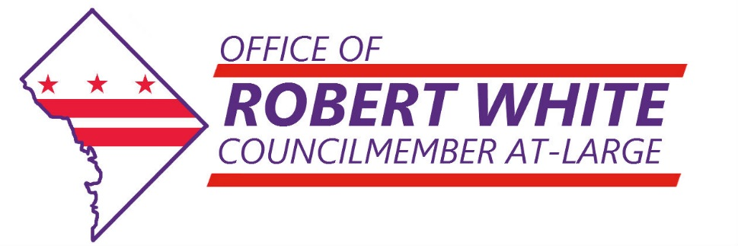

**For Immediate Release:** March 2, 2017

**Contact:** [Daniel Wise](mailto:dwise@dccouncil.us), Communications & Outreach Specialist (202) 256-7154

Follow At-Large Councilmember Robert White

**[cid:image002.png@01D256CF.7C8844D0](https://www.facebook.com/RobertWhiteAtLarge)[cid:image003.png@01D256CF.7C8844D0](https://twitter.com/robertwhite_DC)[cid:image004.png@01D256CF.7C8844D0](https://www.instagram.com/robertwhite_dc/)**

**At-Large Councilmember Robert White Releases Transition Report Detailing His Legislative Plan**

Washington, DC - At-Large Councilmember Robert White today announced the release of his Transition Report detailing his agenda for his first term in office. The Councilmember’s office released the report that capped several months of discussions between the Councilmember and his all-volunteer Transition Committee that started 48 hours after he won the 2016 General Election. Within the Transition Committee, White created four subcommittees that correspond with his priority policy areas: education, affordable housing, workforce development, and returning citizens.

The Councilmember crafted his Transition Committee to include a wide range of viewpoints and backgrounds. White explained, “Some members of my Transition Committee are well-established subject-matter experts who have invested countless hours advocating within the Council building.” He added, though, that he “explored beyond those who are politically involved to bring in some lesser-known stakeholders who could shake up these discussions with fresh perspectives.”

Councilmember White released the Transition Report following a letter he sent to Mayor Muriel Bowser advocating for program funding in her fiscal year 2018 budget proposal. White requested funding for programs within his policy priorities, which are critical to help bridge the city’s economic divides. The Transition Report builds on the letter with concrete legislative goals for his first Council term and aims to promote accountability and transparency in his work.

More specifically, Councilmember White’s legislative agenda will:

* Foster education at every age with a focus on early childhood development, special education, and adult education;
* Open the door to employment by strengthening youth employment, creating new opportunities for unemployed residents, and vetting job training programs;
* Build an affordable city by increasing affordable housing development, preserving the affordable housing stock, and defending tenant rights; and
* Support returning citizens by reorganizing agencies that serve residents who are returning home from prison.

Councilmember Robert White’s Transition Report is attached. White has served the District as an At-Large Councilmember since September 16, 2016. His focus is on education, affordable housing, workforce development, and returning citizens. Additionally, Councilmember White sits on the Committees on Education, Finance and Revenue, Housing and Neighborhood Revitalization, Human Services, and Labor and Workforce Development.

###